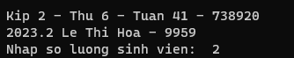
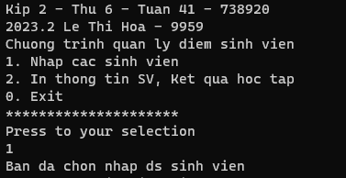
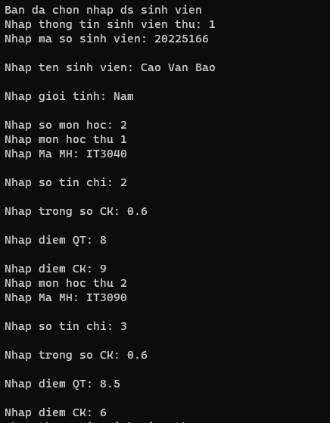
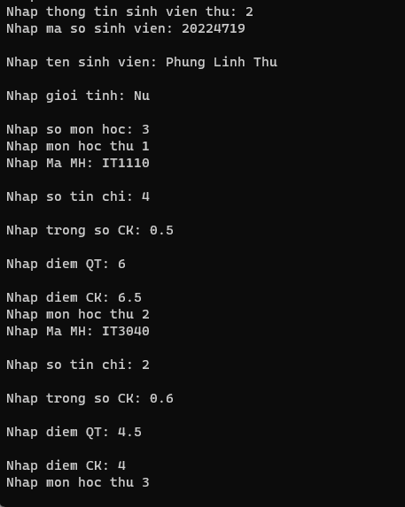
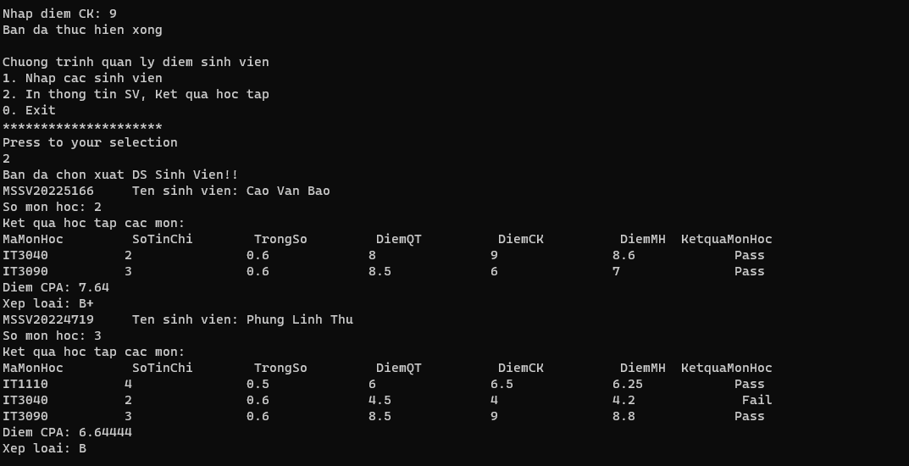
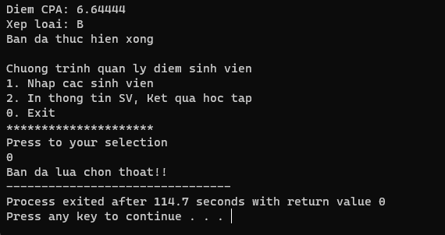

#include<bits/stdc++.h>

using namespace std;

struct MonHoc{
string MaMH;
int soTinChi;
float diemQT;
float diemCK;
float trongSoCK;
float DiemMH;
string ketQuaMH;
};

struct SinhVien{
string MSSV;
string HoTenSV;
string gioiTinh;
int soMonHoc;
vector<MonHoc> DSMonHoc;
float diemCPA;
string xepLoai;
};

void infor(){
cout << "Chuong trinh quan ly diem sinh vien" << endl;
cout << "1. Nhap cac sinh vien" << endl;
cout << "2. In thong tin SV, Ket qua hoc tap " << endl;
cout << "0. Exit" << endl;
cout << "*********************" << endl;
cout << "Press to your selection" << endl;
}

vector<SinhVien> DSSinhVien;
int n;
void inputData(){
cout << "Ban da chon nhap ds sinh vien" << endl;
for (int i = 0; i < n; i++){
SinhVien tempSV;
string s;
getline(cin, s);
cout << "Nhap thong tin sinh vien thu: "<< i+1 << endl;
cout << "Nhap ma so sinh vien: "; getline(cin, tempSV.MSSV) ;
cout << endl << "Nhap ten sinh vien: "; getline(cin, tempSV.HoTenSV);
cout << endl << "Nhap gioi tinh: "; getline(cin, tempSV.gioiTinh);
cout << endl << "Nhap so mon hoc: "; cin >> tempSV.soMonHoc;
for (int k = 0; k < tempSV.soMonHoc; k++){
MonHoc tempMH;
getline(cin, s);
cout << "Nhap mon hoc thu " << k + 1 << endl;
cout << "Nhap Ma MH: "; getline(cin, tempMH.MaMH);
cout << endl << "Nhap so tin chi: "; cin >> tempMH.soTinChi;
do {
cout << endl << "Nhap trong so CK: "; cin >> tempMH.trongSoCK;
}
while (tempMH.trongSoCK < 0 || tempMH.trongSoCK > 1);
cout << endl << "Nhap diem QT: "; cin >> tempMH.diemQT;
cout << endl << "Nhap diem CK: "; cin >> tempMH.diemCK;
tempMH.DiemMH = tempMH.diemCK * tempMH.trongSoCK + tempMH.diemQT * (1 - tempMH.trongSoCK);
if (tempMH.DiemMH > 5){
tempMH.ketQuaMH = "Pass";
}
else tempMH.ketQuaMH = " Fail";
tempSV.DSMonHoc.push_back(tempMH);
}
DSSinhVien.push_back(tempSV);
}
}

void printData(){
cout << "Ban da chon xuat DS Sinh Vien!!" << endl;
for (int i = 0; i < DSSinhVien.size(); i++) {
cout << "MSSV" << DSSinhVien[i].MSSV;
cout << "\t Ten sinh vien: " << DSSinhVien[i].HoTenSV << endl;
cout << "So mon hoc: " << DSSinhVien[i].soMonHoc << endl;
cout << "Ket qua hoc tap cac mon: " << endl;
DSSinhVien[i].diemCPA = 0.0;
int TongSoTC = 0;
vector<MonHoc> dsMH = DSSinhVien[i].DSMonHoc;
cout << "MaMonHoc\t SoTinChi\t TrongSo\t DiemQT\t\t DiemCK\t\t DiemMH\t KetquaMonHoc" << endl;
for (int j = 0; j < dsMH.size(); j++) {
cout << dsMH[j].MaMH << "\t\t" << dsMH[j].soTinChi << "\t\t" << dsMH[j].trongSoCK << "\t\t";
cout << dsMH[j].diemQT << "\t\t" << dsMH[j].diemCK << "\t\t" << dsMH[j].DiemMH << "\t\t" << dsMH[j].ketQuaMH << endl;
TongSoTC += dsMH[j].soTinChi;
DSSinhVien[i].diemCPA += dsMH[j].DiemMH * dsMH[j].soTinChi;
}
DSSinhVien[i].diemCPA = DSSinhVien[i].diemCPA / TongSoTC;
cout << "Diem CPA: " << DSSinhVien[i].diemCPA << endl;
float DiemCPA = DSSinhVien[i].diemCPA;
if (DiemCPA >= 9){
DSSinhVien[i].xepLoai = "A+";
}
if (DiemCPA >= 8.5 && DiemCPA < 9){
DSSinhVien[i].xepLoai = "A";
}
if (DiemCPA >= 7.5 && DiemCPA < 8.5){
DSSinhVien[i].xepLoai = "B+";
}
if (DiemCPA >= 6.5 && DiemCPA < 7.5){
DSSinhVien[i].xepLoai = "B";
}if (DiemCPA >= 5 && DiemCPA < 6.5){
DSSinhVien[i].xepLoai = "C";
}
if (DiemCPA >= 4 && DiemCPA < 5){
DSSinhVien[i].xepLoai = "D";
}if (DiemCPA < 4){
DSSinhVien[i].xepLoai = "F";
}
cout << "Xep loai: " << DSSinhVien[i].xepLoai << endl;
}

}

int main(int argc, char const *argv[])
{
int c;
cout << "Kip 2 - Thu 6 - Tuan 41 - 738920" << endl;
cout << "2023.2 Le Thi Hoa - 9959" << endl;
cout << "Nhap so luong sinh vien: ";
cin >> n;
cout << "Kip 2 - Thu 6 - Tuan 41 - 738920" << endl;
cout << "2023.2 Le Thi Hoa - 9959" << endl;
while (1)
{
infor();
cin >> c;
switch (c){
case 1: inputData();
break;
case 2: printData();
break;
case 0: cout << "Ban da lua chon thoat!!";
return 0;
default:
break;
}
cout << "Ban da thuc hien xong" << endl;
cout << endl;
}
return 0;
}

